|  |
| --- |
| Assignment#2: Product Backlog, Epics, Stories and Estimates |
| Key |

PLease refer to the requirements given in the scenario CRM Sales Managemement software and create the PRODUCT BACKLOG CONTAINING epics AND stories, AND ESTIMATE stories IN story points.

guidelines to be followed:

* refer to the list of requirements given in the scenario and understand the requirements from the end users point of views.
* add these requirements as epics and stories, and create a product backlog in jira.
* discuss in the group and estimate stories in the story points by using planning poker technique.

Key

* Product backlog

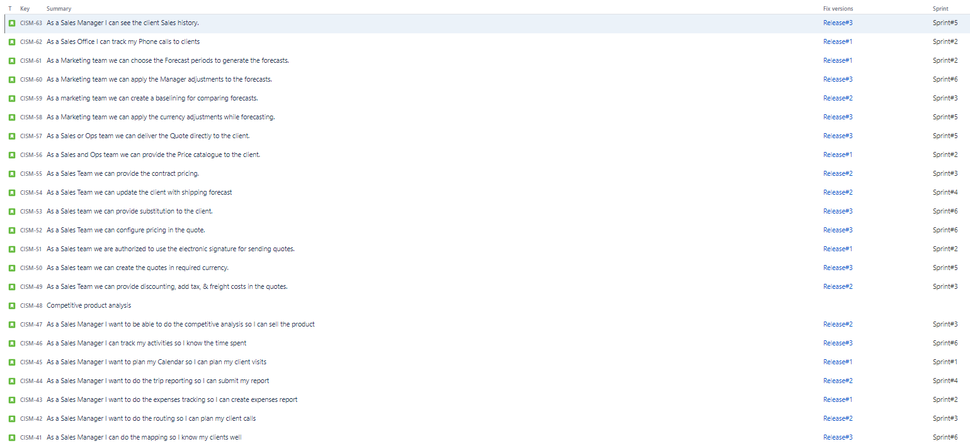

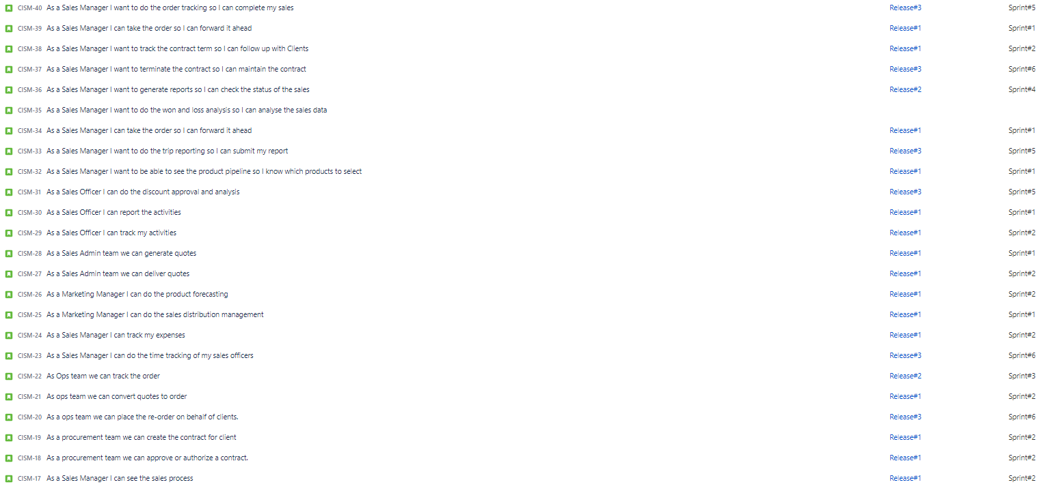





* epics

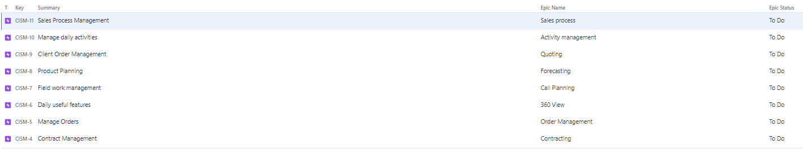

* stories with story point estimates

